**Create and Manage Groups in Windows 10**

**Task 1**

Wanda and Duncan do not want to let Ramona in on their best inside-jokes! To prevent this, they will be added to a group called “Inside Joke Club”. Then, only members of this group will be permitted to view the contents of the “Wanda & Duncan’s Best Inside-Jokes” folder!

1. Open the Microsoft Management Console by double-clicking on the shortcut icon created in part 2:

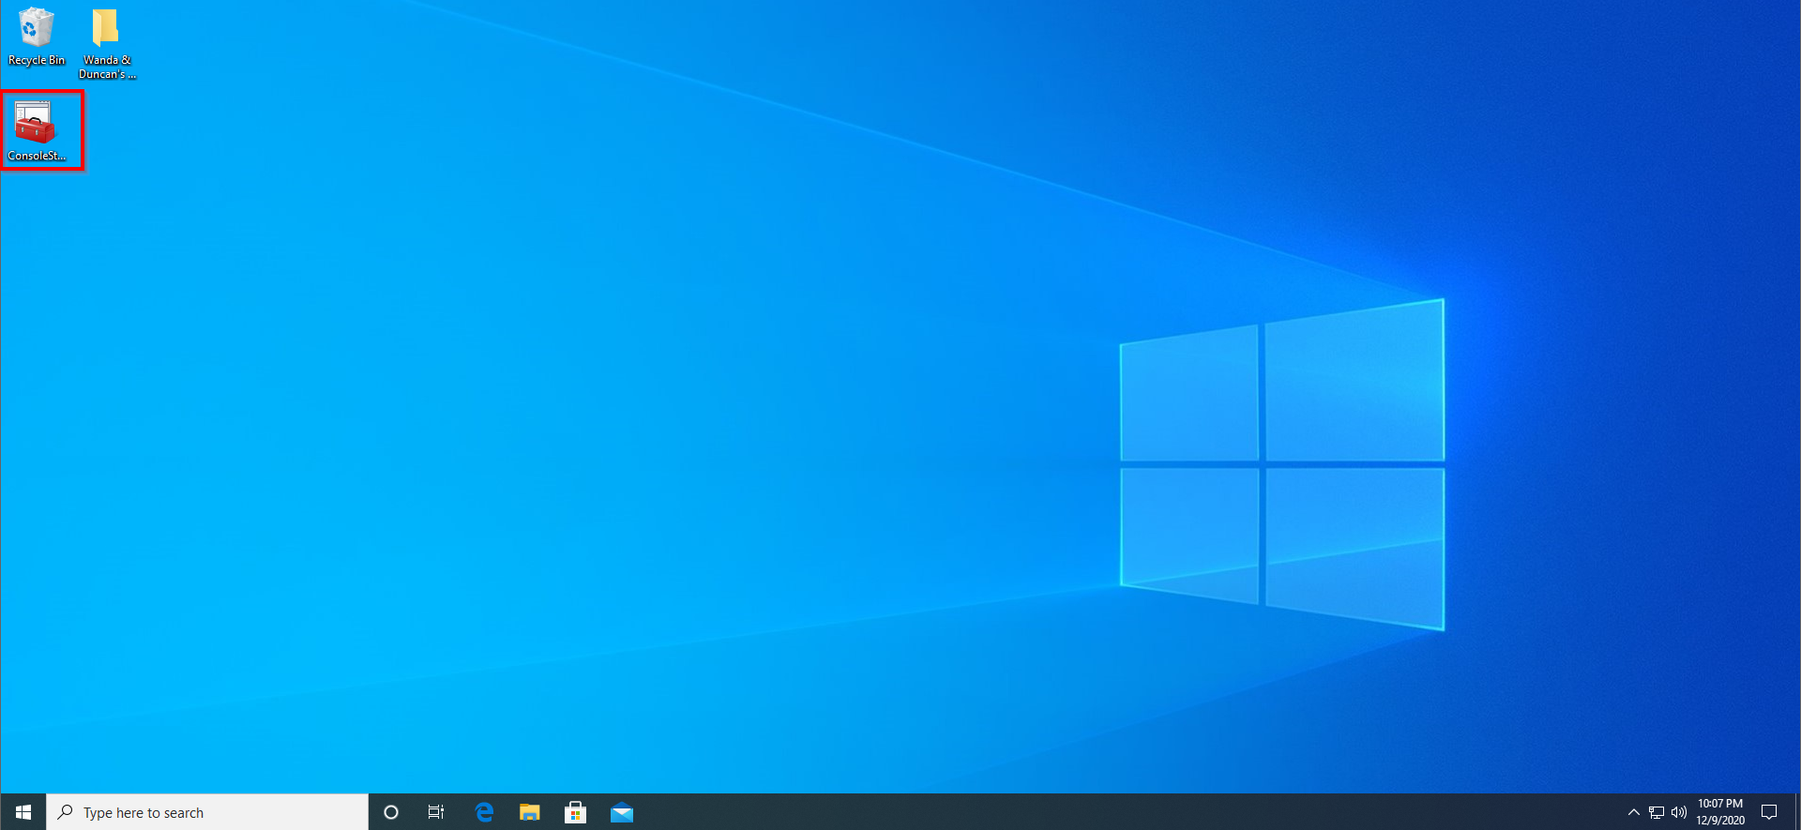

1. When the “User Account Control” window pops up, click **Yes**:

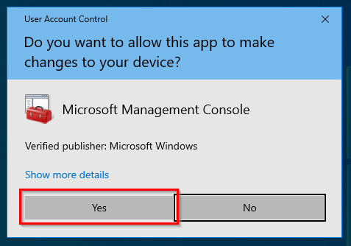

1. Double-click on **Local Users and Groups (Local)** to reveal the Groups folder. Double-click on the **Groups** folder:

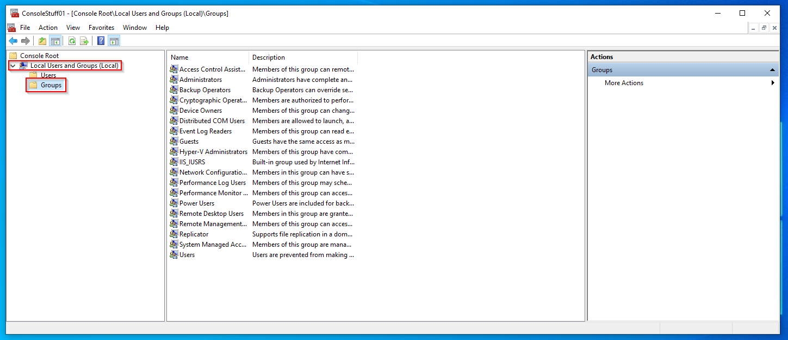

1. Right-click anywhere within the blank space of the middle section of the console window. Click **New Group…**

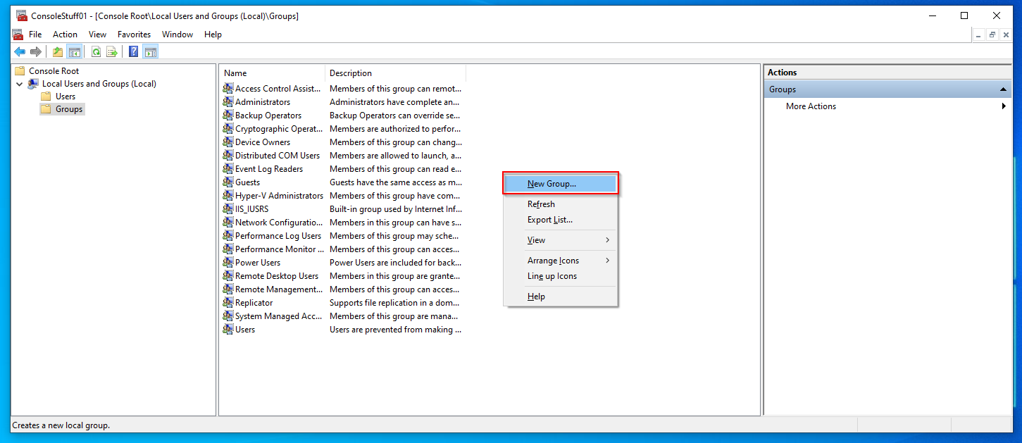

1. Enter a “Group name:” (in this case, “Inside Jokesters”) and a “Description:”, then click **Add…** to add members to the group:

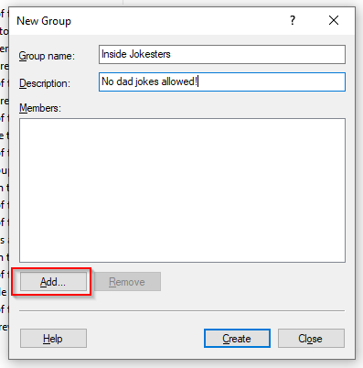

1. Add multiple users to the group at once by separating each username with a semicolon **;** then click **OK**:

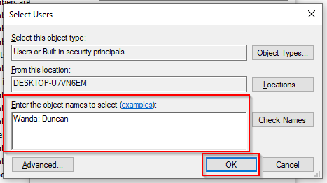

1. Click **Create,** then **Close**:

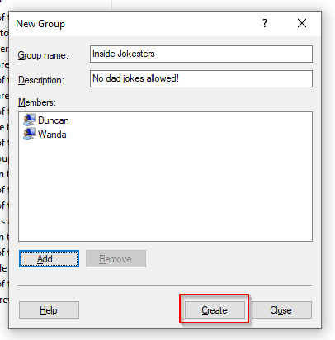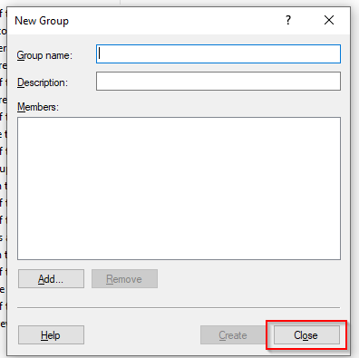

1. Click **File**, then **Save** to save the changes made to the console:

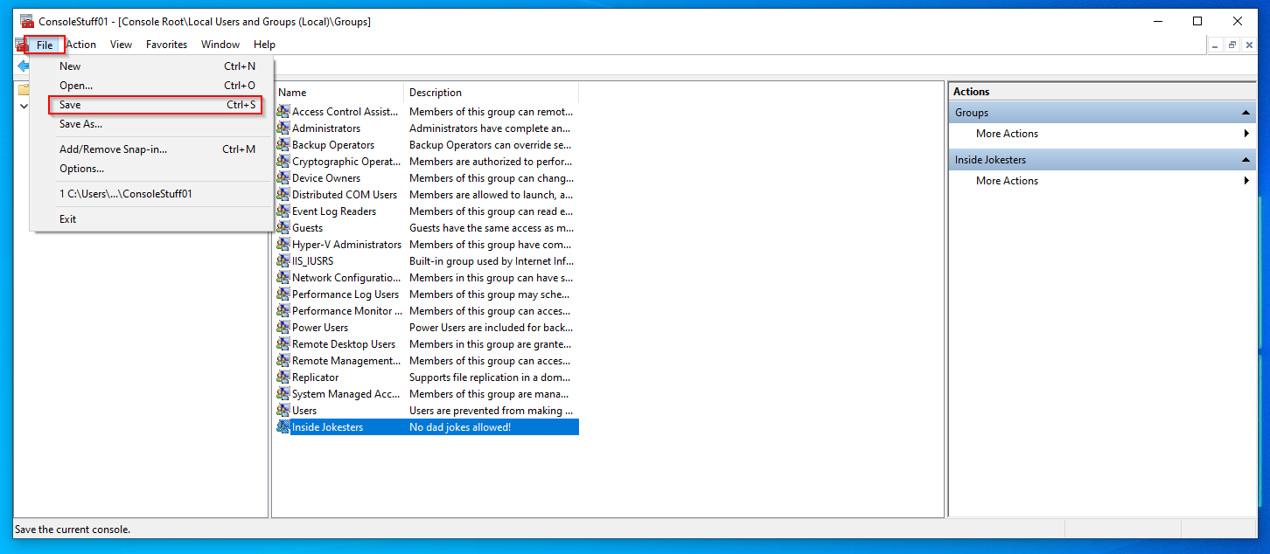

1. Right-click on the file to be assigned permissions (in this case, “Wanda & Duncan’s Best Inside-Jokes”), then click **Properties**:

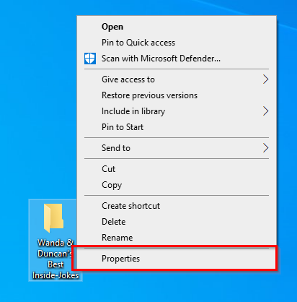

1. Click on the **Security** tab:

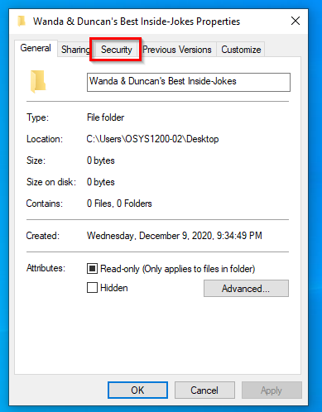

1. Click on **Edit…**, then in the new window that opens click **Add…**

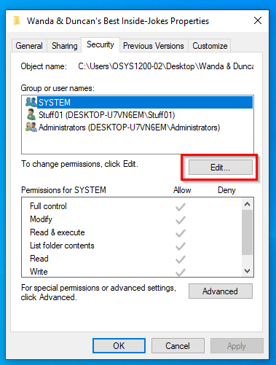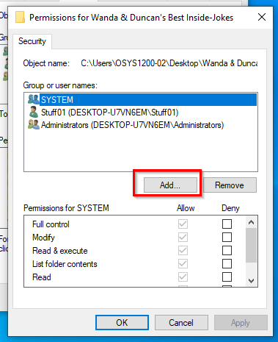

1. Enter the name of the group that will be allowed to access this folder (in this case, “Inside Jokesters”), then click **OK**:

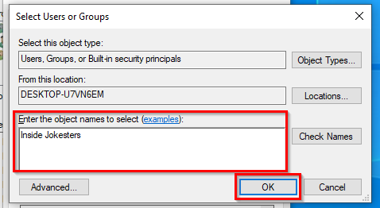

1. Click **OK** in the previous window:

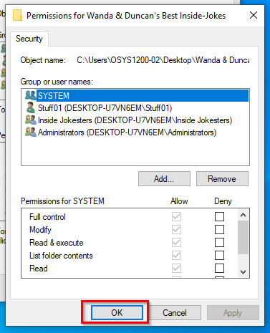

1. Sign into each Wanda and Duncan’s accounts to confirm they can view the folder:

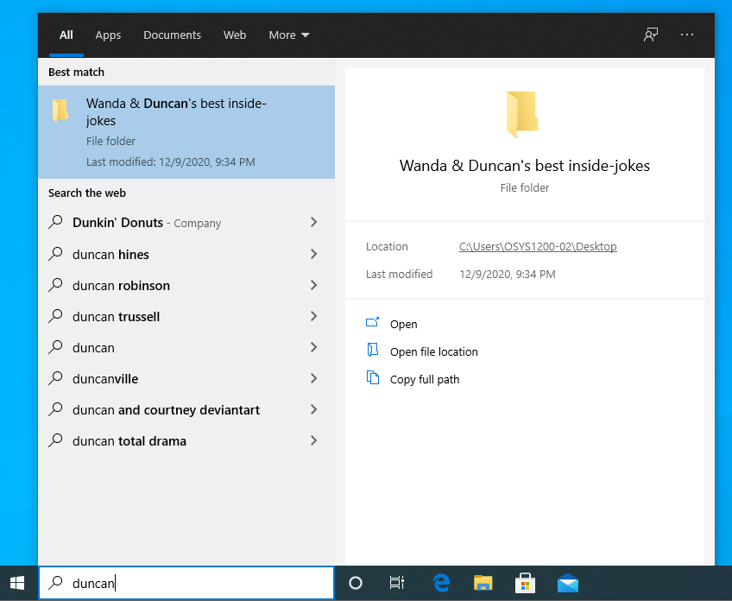

1. Sign into Ramona’s account to ensure she cannot view it:

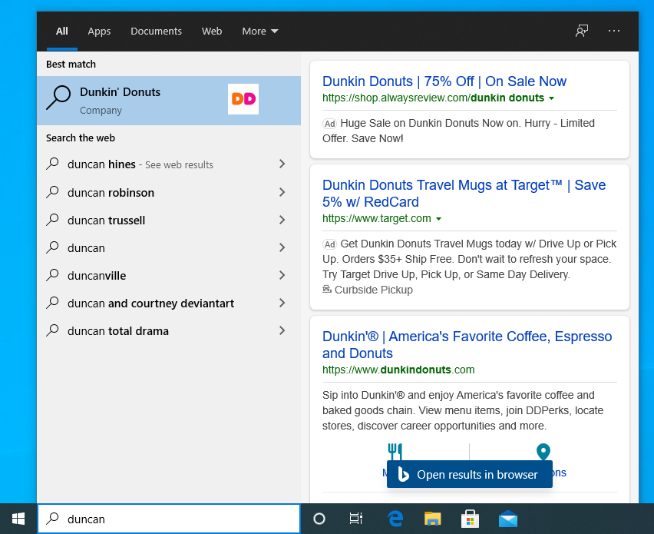

**Task 2**

Wanda will be made an administrator of Stuff01, and Barry an administrator of Stuff02, by being assigned to the “Administrators” group on their respective devices:

1. Return to the console via the desktop shortcut. Click **Yes** when prompted by the User Account Control pop-up:



1. Double-click the **Groups** folder below the Local Users and Groups (Local) snap-in. Right-click on **Administrators**, then **Add to Group…**

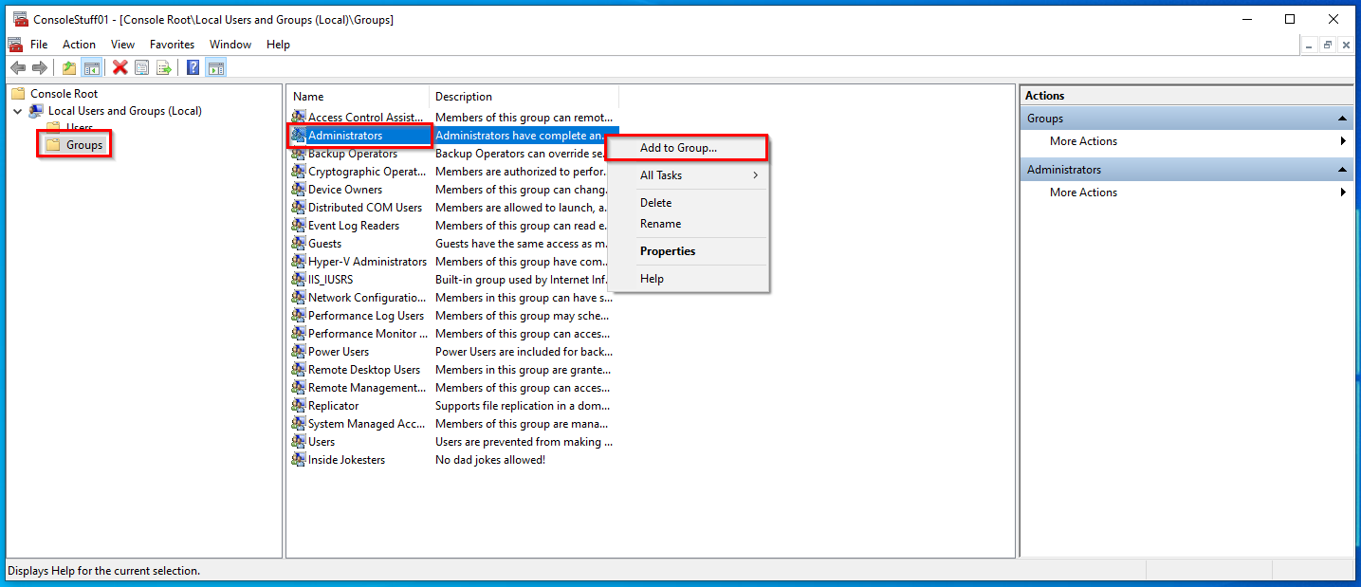

1. In the new window that opens, click **Add…**

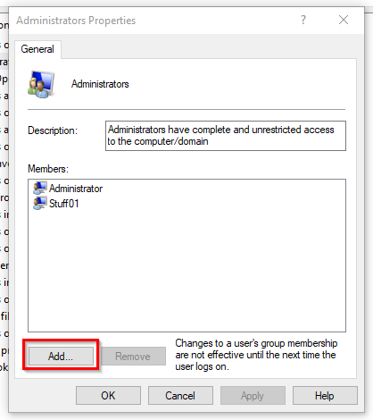

1. Enter the name of the user to be assigned to the Administrator group (in this case, “Wanda”), then click **OK:**

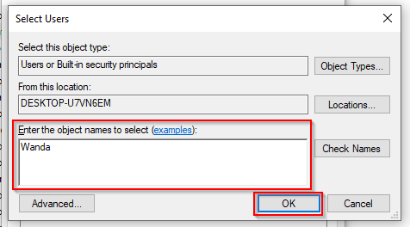

1. Click **OK** in the previous window as well:

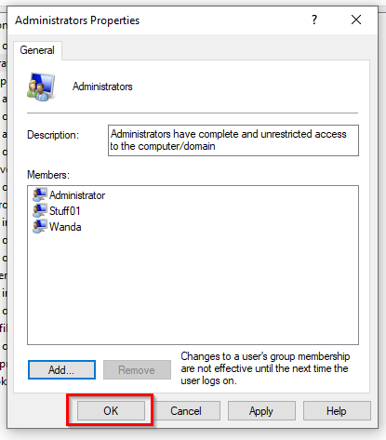

1. Wanda is now a member of the Administrators group. Click File then Save to save the changes. Confirm that Wanda is now an Administrator by signing into her account and viewing her Account Info (type “your info” into the Windows search bar and hit **enter**):

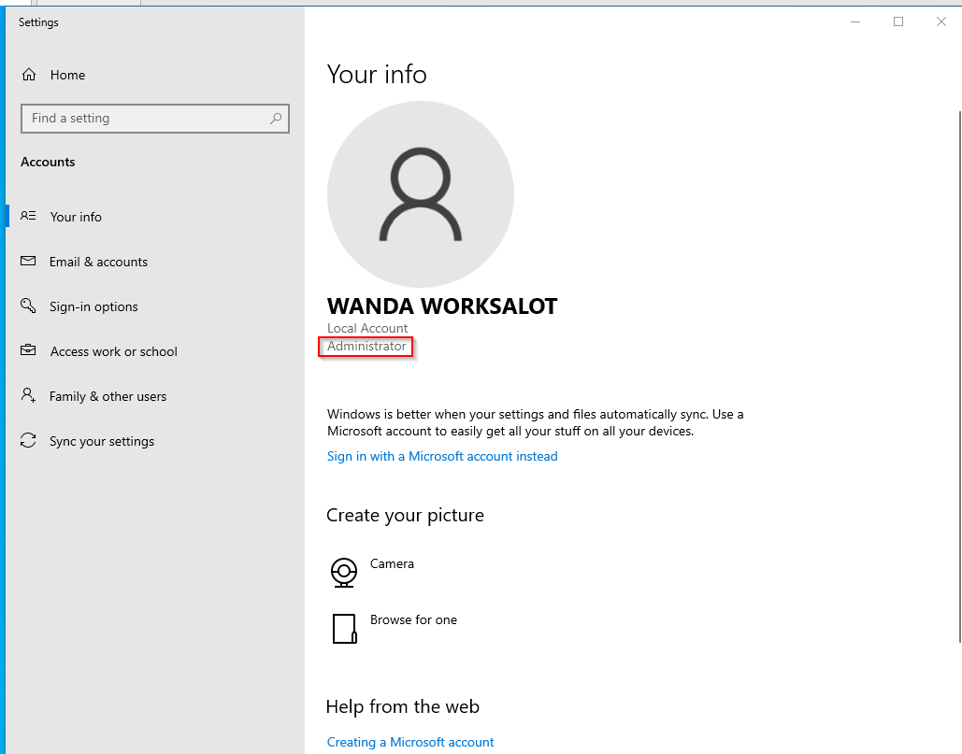

1. Repeat **steps 1-6** for user, Barry, on Stuff02:

